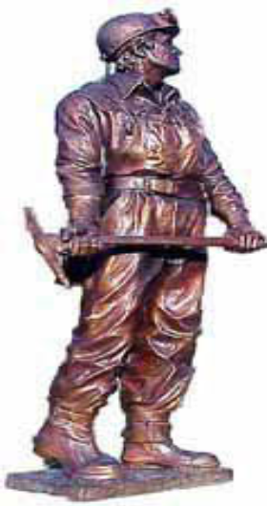
VA MIDDLE SCHOOL BEARCAT ACADEMY FAMILY FIELD TRIP
Who: VA Middle School Bearcat Academy Members and their Family
What: Field trip to Harlan, KY to tour a mine, museum tour and dinner.
When: December 9th 10:00 AM-9:00 PM (return time is approximate)
Where: Port 31- Harlan, KY
Join us for a fun Bearcat Academy Family event that is sure to be a blast! This field trip is going to be a fun filled day! We will leave VA Middle School at 10:00 AM, please plan to arrive by 9:45. We will then head out to Harlan, KY to visit Port 31 mine. Your family will be able to go 1500 feet into a mine and will learn about the history of mines via animatronics. After this fun adventure we will go to the Benham Coal Mining Museum where a guide will show around the museum. Then, we will be off to have a buffet supper at the Benham Schoolhouse Inn. Finally, there will be a Christmas surprise on the way back to school.
Bearcat Academy will cover the cost of the academy student and two parents. If any additional adults or students that are not enrolled in Bearcat Academy at VA Middle School would like to attend they will need to pay at the different stops. There will be a gift shop and we may stop for snacks if you would like to bring additional money.

**Keep this page so you will remember date and times!

Harlan, KY Coal Mining Family Field Trip Sign Up Form

Bearcat Academy Member: _________________________________________
Number of parents attending: _______________________________________
Number of other children attending: __________________________________
TOTAL ATTENDING INCLUDING VMS STUDENT: ___________________________

Costs for extra people attending:
Port 31: Students: $6.18 Adults: $15.45
Museum: Students: $4 Adults: $8
Buffet Supper : $16pp

***Please return this form to Mrs. Buchanan in the library by December 1st.

