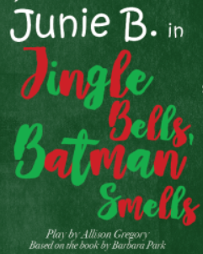
VA MIDDLE SCHOOL BEARCAT ACADEMY FAMILY FIELD TRIP
Who: VA Middle School Bearcat Academy Members and their Family
What: Theater Bristol Presents: Junie B Jones- Jingle Bells Batman Smells
When: December 2nd
Where: Theater Bristol

Join us for a fun Bearcat Academy Family event that is sure to be a blast! VA Middle School’s very own, Whitney Brooks and Mykella Bryant, will star in the performance as Junie B and Lucille! We will meet at the bus circle on December 2nd at 9:30 AM and the bus will pull out at 9:45 The performance begins at 10:30 and should end around 12:30. We plan to return to the school by 1:00.

Bearcat Academy will cover the cost of the academy student and two parents. If any additional adults or students that are not enrolled in Bearcat Academy at VA Middle School would like to attend the cost is $5 each. The money must be paid at the time you return this form. Snacks MAY be available for purchase if you would like to bring extra money.

**Keep this page so you will remember date and times!

Junie B Jones- Jingle Bells Batman Smells Family Field Trip Sign Up Form

Bearcat Academy Member: _________________________________________
Number of parents attending: _______________________________________
#__________ Extra tickets need to be purchased. Cost: $5 each. Payment must be made when this form is turned in.

***Please return this form to Mrs. Buchanan in the library by November 8th.

